 

Learning From Data

Support Vector Machine “**SVM**” (Task 3)

Banknote Authentication Problem

|  |  |
| --- | --- |
| Name | ID |
| فؤاد سيد فؤاد | 20200384 |
| حسن سمير حسن | 20200154 |
| حسن تامر علي | 20200152 |
| أحمد سامح أحمد | 20200015 |
| سارة صاموئيل لمعي | 20200217 |

اشراف: ا. د. الشيماء الجندي

2022م-2023م

Loss Error For Each Epoch (Hard Margin)

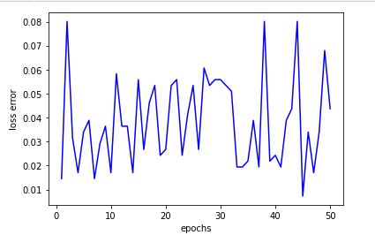

Confusion Matrix (Hard Margin)

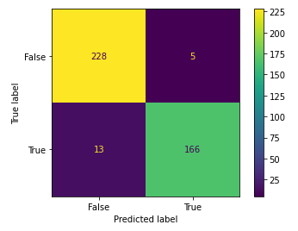

* True Positive = 228
* False Positive = 5
* True Negative = 166
* False Negative = 13

ROC Curve (Hard Margin)

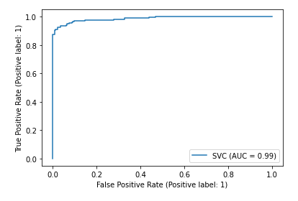

* **Accuracy Score for Hard Margin = 95.63%**

An ROC Curve (Receiver Operating Characteristic Curve) is a graph showing the performance of a classification model at all classification thresholds. This curve plots two parameters:

* True Positive Rate
* False Positive Rate

True Positive Rate (TPR) is a synonym for recall and is therefore defined as follows:

* TPR = (TP)/(TP+FN)

False Positive Rate (FPR) is defined as follows:

* FPR = (FP)/(FP+TN)

An ROC curve plots TPR vs. FPR at different classification thresholds. Lowering the classification threshold classifies more items as positive, thus increasing both False Positives and True Positives. The following figure shows a typical ROC curve.

Loss Error For Each Epoch (Soft Margin)

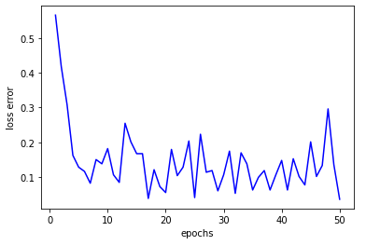

Confusion Matrix (Soft Margin)

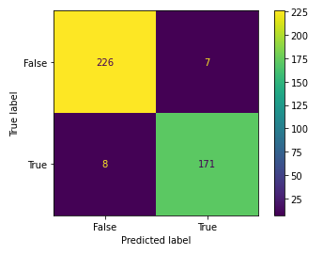

* True Positive = 226
* False Positive = 7
* True Negative = 171
* False Negative = 8

ROC Curve (Soft Margin)

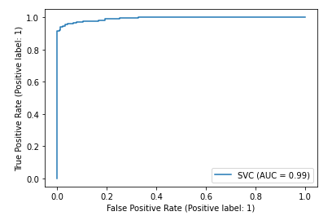

* **Accuracy Score for Soft Margin =** **96.35%**

An ROC Curve (Receiver Operating Characteristic Curve) is a graph showing the performance of a classification model at all classification thresholds. This curve plots two parameters:

* True Positive Rate
* False Positive Rate

True Positive Rate (TPR) is a synonym for recall and is therefore defined as follows:

* TPR = (TP)/(TP+FN)

False Positive Rate (FPR) is defined as follows:

* FPR = (FP)/(FP+TN)

An ROC curve plots TPR vs. FPR at different classification thresholds. Lowering the classification threshold classifies more items as positive, thus increasing both False Positives and True Positives. The following figure shows a typical ROC curve.